CPP ASSIGMENT

Operator Overloading

Q1.) Write a C++ program to compute area of right angle triangle, equilateral triangle, isosceles triangle using function overloading concept**.**

**Code:**

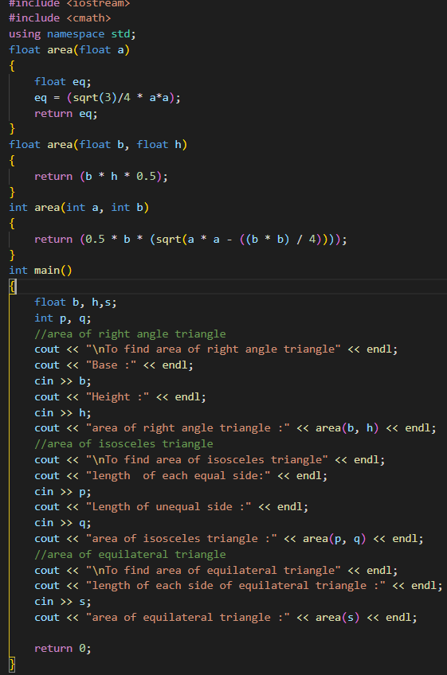

**Output:**

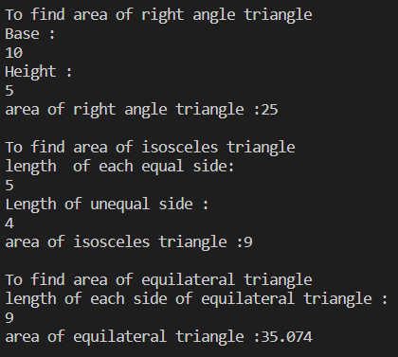

Q2.) Consider a publishing company that markets both book and audio cassette version to its works. Create a class Publication that stores the title (a string) and price (type float) of a publication. Derive the following two classes from the above Publication class: Book which adds a page count (int) and Tape which adds a playing time in minutes (float). Each class should have get_data() function to get its data from the user at the keyboard. Write the main() function to test the Book and Tape classes by creating instances of them asking the user to fill in data with get_data() and then displaying it using put_data()**.**

**Code:**

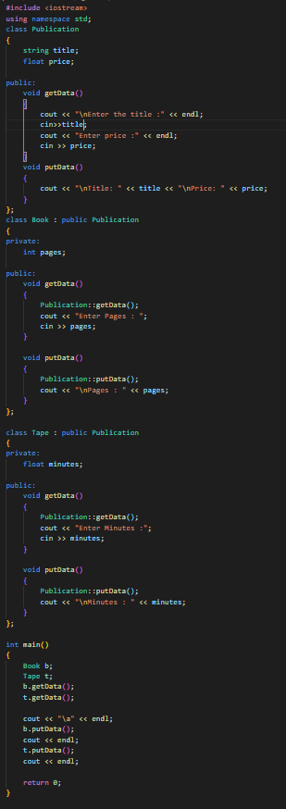

**Output:**

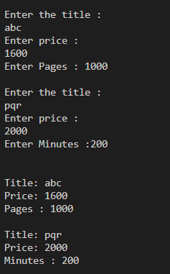

Q3.) Complete the code by implementing default function arguments.

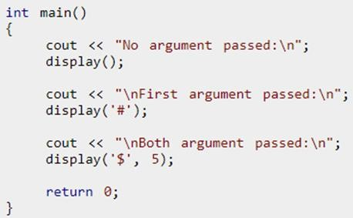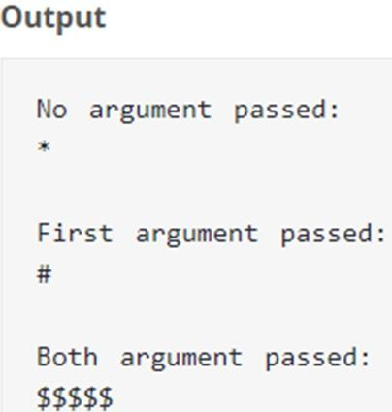

**Complete code:**

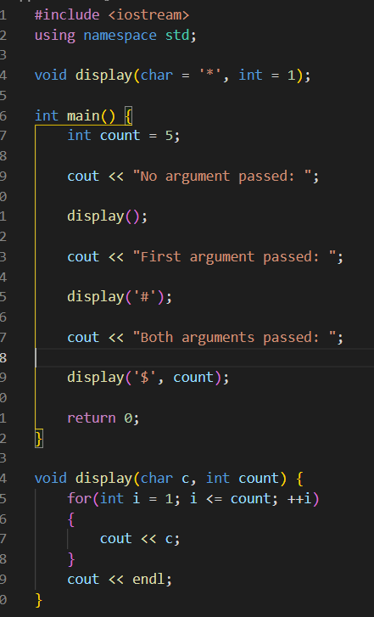

Q4.) Define a class named Complex with properties (real and imaginary).

* Use CONSTRUCTOR OVERLOADING and THIS POINTER to initialize data members of this class.
* void display () to display complex number.
* Complex sum (Complex) to add two complex numbers.

**Code:**

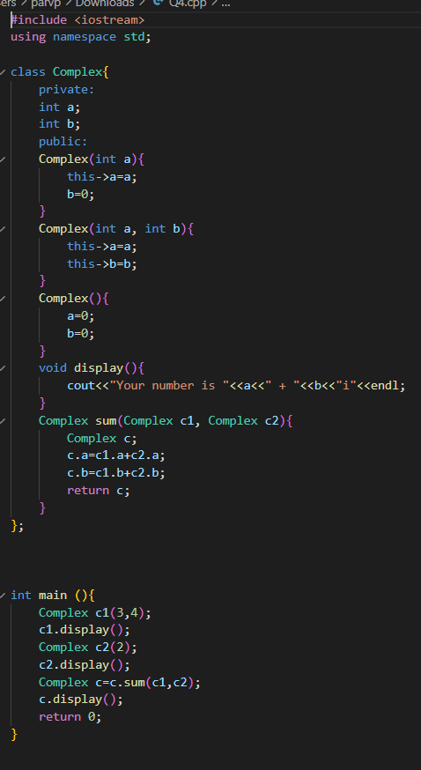

**Output:**



Q5.) WAP that illustrates the use of copy constructor.

**Code:**

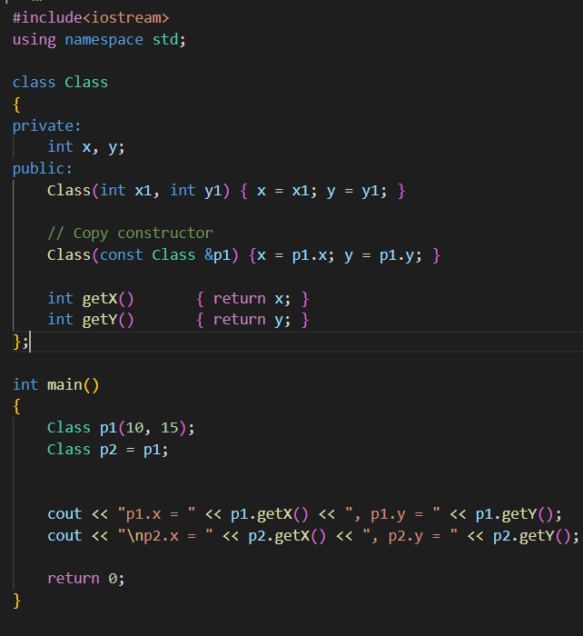

**Output:**

